Experiment 7 Torques lab ‌

This lab uses parts of the Balancing Act simulation from PhET Interactive Simulations at University of Colorado Boulder, under the CC-BY 4.0 license.
https://phet.colorado.edu/sims/html/balancing-act/latest/balancing-act_en.html

Learning Goals: Students will be able to:
- Describe the factors that determine whether two objects will balance each other
- Predict how changing the position of a mass on the balance will affect the motion of the balance
- Use a balance to the find the masses of unknown objects

Advance reading: Sections 8.3 & 8.4 of text (Hewitt 12th edition).

Equations of interest:

Torque = lever arm (distance) $×$ applied force.

When the applied force is caused by a weight.

Torque = lever arm distance $×$ weight = lever arm distance $×$mass $×$acceleration of gravity

Sum of torques = zero => Torque on LHS of fulcrum = Torque on RHS of fulcrum

Develop your understanding: Explore the Intro screen, then explore to develop your own ideas about what determines how objects balance each other.

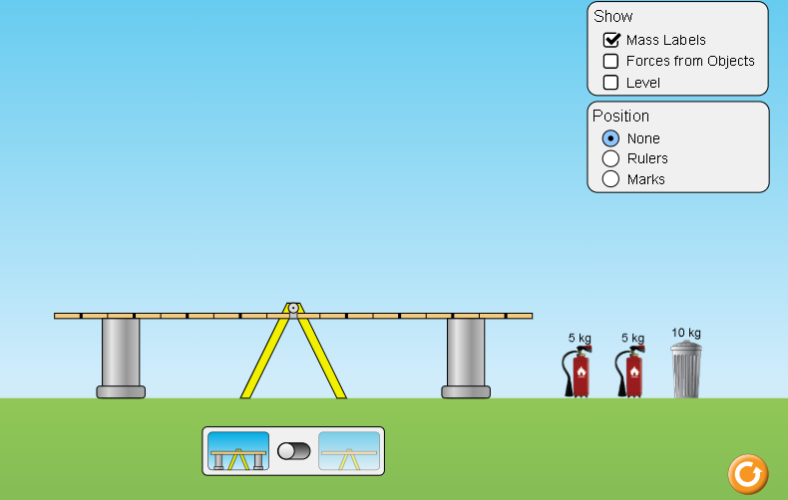

Explain your understanding: Use your own words and captured images from the simulation to show you can:

- Make two same mass objects balance in at least two different ways.
  - Place captured images here

  - Explain why it makes sense that there is more than one way to make the objects balance.

- Make two different mass objects balance in at least two different ways.
  - Place captured images here

  - Explain why it makes sense that there is more than one way to make the objects balance.

Test your understanding: Open the Balance Lab screen, use some different objects and masses to apply your ideas.
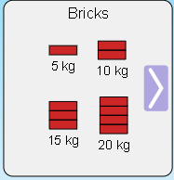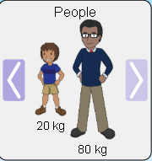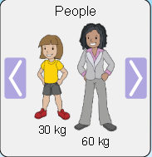
- Make two same mass objects balance in at least two different ways.
  - Place captured images here

  - Using the definition of torque, calculate the torques for both sides and show that the sum of the torques is equal to zero. You only need to show one set of calculations. Show all work.

- Make two different mass objects balance in at least two different ways.
  - Place captured images here

  - Using the definition of torque, calculate the torques for both sides and show that the sum of the torques is equal to zero. You only need to show one set of calculations. Show all work.

An examination of center of mass and the one person see-saw:

- This part closely parallels ‘Check Point” # 2 from section 8.4 of text (page 142, Hewitt 12th edition). This ‘Check Point’ deals with the center of mass of a meter stick.

- Use the figure below and ‘Check Point” # 2 to determine the mass of the meter stick. Center of mass of meter stick is at 50cm.

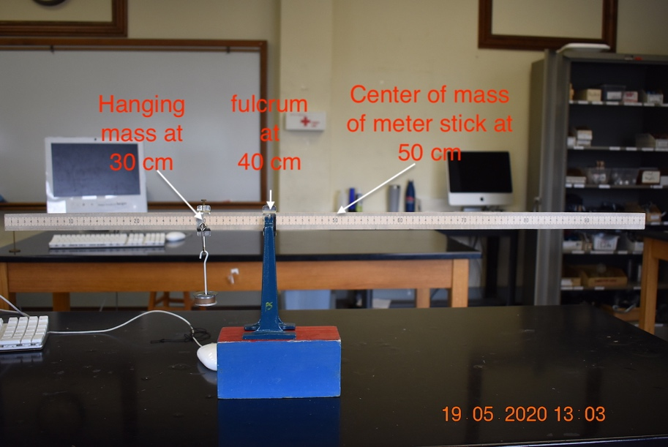

- The mass total mass hanging on the left hand side (LHS) of the meter stick can be found from the image below.

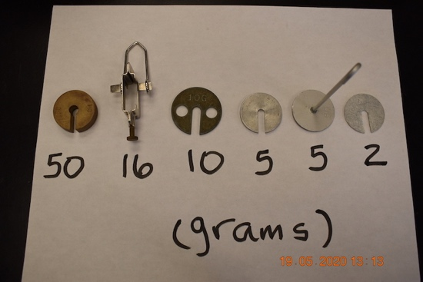

- Mass of meter stick = ________________. Explain your answer.

- Using torque arguments (i.e., sum of torques must be equal to zero) find the hanging mass for the following configuration. Mass of meter stick is what you calculated above in part c (although this part can be solved without the mass of meter stick).

Center of mass and fulcrum are in the same positions as in part a.

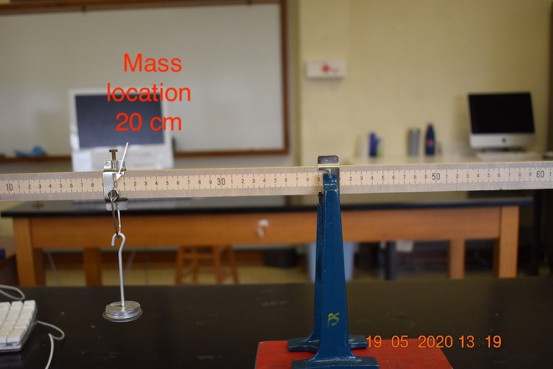

- Total mass on LHS of meter stick = ________________. Explain your answer.

- Using torque arguments (i.e., sum of torques must be equal to zero) find the hanging mass for the following configuration. Mass of meter stick is what you calculated above in part c above (although this part can be solved without the mass of meter stick).

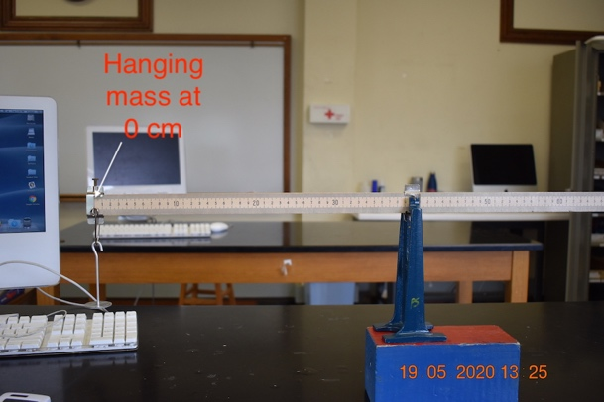

- Total mass on LHS of meter stick = ________________. Explain your answer.

A practical examination of torque using a wrench on a nut

- This part of the lab will examine the concept that the lever arm distance in torque calculations is not only a function of how long the handle of a wrench is, but also a function of the direction of applied force. We will use Figure 8.20 (below) from the text in this part of the lab.

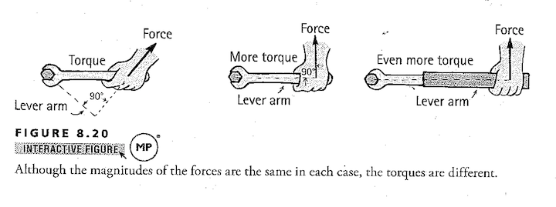
- Is the nut being tightened or loosened? Explain.

- Using the lever arm distance on the middle diagram as your reference torque and assuming the force is the same in all 3 situations, determine the relative torque being applied to the LHS and RHS figures. Show all work and explain your answers.

